КЫРГЫЗСКИЙ ТЕХНИЧЕСКИЙ УНИВЕРСИТЕТ им. И. Раззакова

ФАКУЛЬТЕТ ИНФОРМАЦИОННЫХ ТЕХНОЛОГИЙ

Кафедра «ПРОГРАММНОЕ ОБЕСПЕЧЕНИЕ КОМПЬЮТЕРНЫХ

СИСТЕМ»

Дисциплина

Методы оптимизации

Отчет

по практической работе №4

«Разработка ПО для поиска **максимальной и минимальной точки *экстремума*** на основе метода: ***Golden Section Search Method***»

Выполнил: студент группы ПИ-2-16

Калыков Алишер

Проверил: кандидат технических наук, профессор

Тен Иосиф Григорьевич

Оглавление

Раздел №1 Наименование работы 3

Раздел №2 Спецификация проблемы 3

Раздел №3 Спецификация метода 4

Раздел №4 Стадии проектирования системы 5

Раздел №5 Документирования этапов проектирования интерфейсной формы системы 7

Раздел №6 Стадии конструирования ПО 10

Раздел №7 Тестирование 15

# Раздел №1 Наименование работы

Найти решение задачи оптимизации для произвольной заданной нелинейной целевой функции f(x) с заданной допустимой погрешностью Tolerance не более величины 1E–28 методом Золотого Сечения (Golden Section Search Method). Целевая функция f(x) имеет произвольный аналитический вид, составленный из математических функций (полиномов различных степеней, тригонометрических – sin(x), cos(x), exp(x), ln(x), log(x) и. т. д.), которая имеет математический смысл, и для которой существует хотя бы одно решение задачи. Описание Golden Section Search Method – приведено по книге “SCIENTIFIC COMPUTING. An Introductory Survey. Michael T. Heath. University of Illinois at Urbana-Champaign. 1997 by The McGraw-Hill Companies. ISBN 0-07-027684-6”.

# Раздел №2 Спецификация проблемы

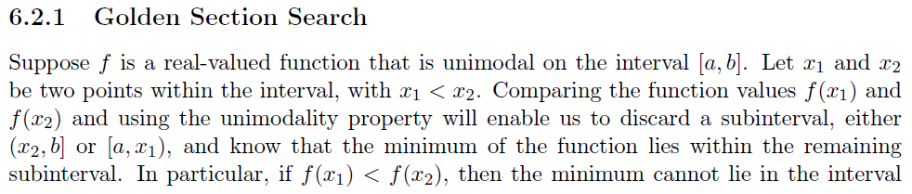 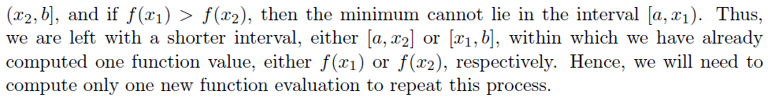 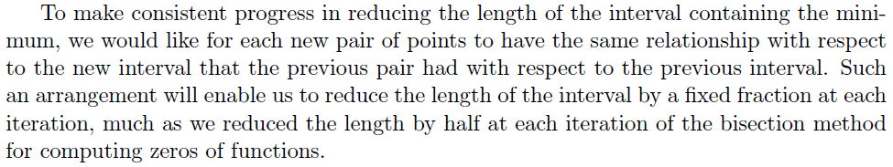 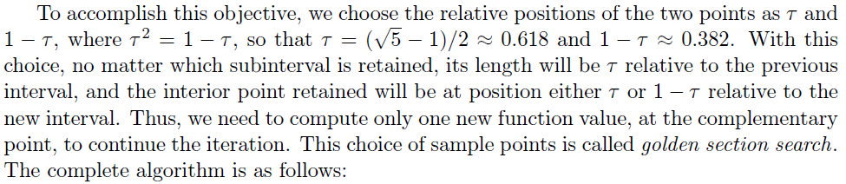

# Раздел №3 Спецификация метода

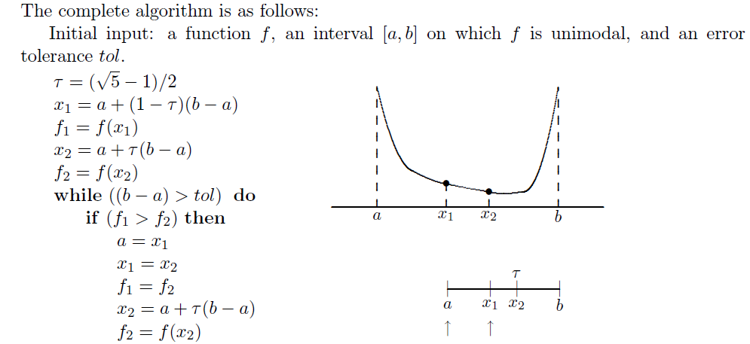 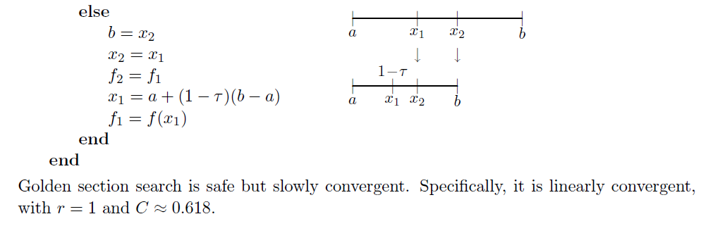

# Раздел №4 Стадии проектирования системы

1. Разработка блок-схемы Pocket Search Method find minimum:



1. Разработка блок-схемы Pocket Search Method find maximum:



1. Разработка пользовательского интерфейса.

Форма для взаимодействия пользователя с программой представлена ниже:

# Раздел №5 Документирования этапов проектирования интерфейсной формы системы

1. Документирование процесса задания свойств элементов интерфейсной формы системы

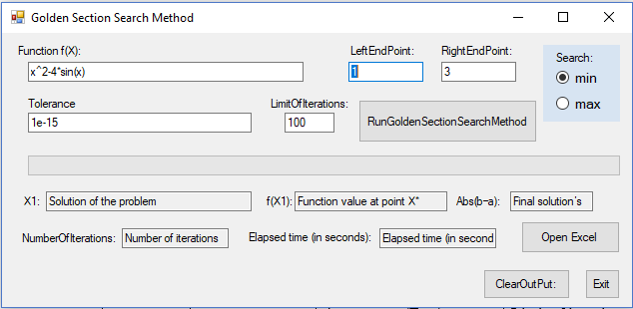

|  |  |  |  |
| --- | --- | --- | --- |
| **Number of control** | **Control** | **Property** | **Setting** |
| 1 | Label | Appearance (Text) | Function f(x): |
| Design (Name) | Label1 |
| 2 | Textbox | Appearance (Text) | x^2-4*sin(x) |
| Design (Name) | funcBox |
| 3 | Label | Appearance (Text) | LeftEndPoint: |
| Design (Name) | LeftEndPointBox |
| 4 | Textbox | Appearance (Text) | 1 |
| Design (Name) | LeftEndPointBox |
| 5 | Label | Appearance (Text) | RightEndPoint: |
| Design (Name) | LabelRightEndPoint |
| 6 | Textbox | Appearance (Text) | 3 |
| Design (Name) | RightEndPointBox |
| 7 | Label | Appearance (Text) | LimitOfIterations: |
| Design (Name) | LabelLimitOfIterations |
| 8 | Textbox | Appearance (Text) | 100 |
| Design (Name) | k_maxBox |
| 9 | Label | Appearance (Text) | Tolerance |
| Design (Name) | LabelTolerance |
| 10 | Textbox | Appearance (Text) | 1e-15 |
| Design (Name) | ToleranceBox |
| 11 | Button | Appearance (Text) | RunBisectionMethod |
| Design (Name) | ButtonRunGoldenMethod |
| 12 | ProgressBar | Behavior (Visible) | False |
| Design (Name) | ProgressBar1 |
| 13 | Label | Appearance (Text) | X1: |
| Design (Name) | LabelRootOfEquation |
| 14 | Textbox | Design (Name) | SolutionOfTaskBox |
| Appearance (Text) | Solution of the problem |
| **Behavior (ReadOnly)** | True |
| 15 | Label | Appearance (Text) | f(X1): |
| Design (Name) | LabelFunctionValue |
| 16 | Textbox | **Behavior (ReadOnly)** | True |
| Appearance (Text) | Function value at point X1 |
| Design (Name) | ValueOfFunctionBox |
| 17 | Label | Appearance (Text) | NumberOfIterations: |
| Design (Name) | Label NumberOfIterations |
| 18 | Textbox | **Behavior (ReadOnly)** | True |
| Appearance (Text) | Number of iterations |
| Design (Name) | NumberOfIterationsBox |
| 19 | Label | Appearance (Text) | Abs(b–a): |
| Design (Name) | LabelAbsError |
| 20 | Textbox | **Behavior (ReadOnly)** | True |
| Appearance (Text) | Final in accurancy |
| Design (Name) | AbsErrorBox |
| 21 | Button | Appearance (Text) | ClearOutPut: |
| Design (Name) | ButtonClearOutPut |
| 22 | Textbox | **Behavior (ReadOnly)** | True |
| Appearance (Text) | Elapsed time(in second) |
| Design (Name) | elapsedTime |
| 23 | Label | Appearance (Text) | Elapsed time (in seconds): |
| Design (Name) | Label3 |
| 24 | Label | Appearance (Text) | empty |
| Design (Name) | Label4 |
| 28 | RadioButton | Appearance (Checked) | True |
| Appearance (Text) | min |
| Design (Name) | minRadioButton |
| 29 | RadioButton | Appearance (Checked) | False |
| Appearance (Text) | max |
| Design (Name) | maxRadioButton |
| 30 | Button | Appearance (Text) | Open Excel |
| Design (Name) | openExcel |
| Tooltil | Открыть Excel файл, чтобы увидеть график функции на отрезке [" & LeftEndPointBox.Text() & ";" & RightEndPointBox.Text() & "]" |

# Раздел №6 Стадии конструирования ПО

1. Код программы на Visual Basic.NET, ***ассоцированный с интерфейсной формой*** “PocketForm.vb”, который ***реализует функции ввода и вывода данных*** и составляет Public Class “GoldenForm”.

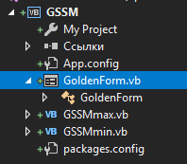



*********************Outset of the “Public Class GoldenForm”

Option Explicit On

Imports System.Math

Imports info.lundin.math

Imports System.Threading

Imports System.IO

Imports Microsoft.Office.Interop.Excel

Imports excel = Microsoft.Office.Interop.Excel

Imports app = Microsoft.Office.Interop.Excel.Application

Public Class GoldenForm

Sub Clean()

SolutionOfTaskBox.Text = "Solution Of Task"

ValueOfFunctionBox.Text = "Value Of Function"

NumberOfIterationsBox.Text = "Number Of Iterations"

elapsedTime.Text = "Elapsed time (in seconds)"

AbsErrorBox.Text = "Final solution’s"

Label4.Text = ""

End Sub

Private Sub GoldenForm_Load(sender As Object, e As EventArgs) Handles MyBase.Load

Label2.Text = ""

SolutionOfTaskBox.Text = "Solution of the problem"

ValueOfFunctionBox.Text = "Function value at point X*"

NumberOfIterationsBox.Text = "Number of iterations"

elapsedTime.Text = "Elapsed time (in seconds)"

AbsErrorBox.Text = "Final solution’s"

Label4.Text = ""

End Sub

Private Sub ButtonExit_Click_1(sender As Object, e As EventArgs) Handles ButtonExit.Click

Close()

End Sub

Private Sub ButtonClearOutPut_Click(sender As Object, e As EventArgs) Handles ButtonClearOutPut.Click

Clean()

End Sub

Private Sub RunGoldenSectionSearchMethod_Click(sender As Object, e As EventArgs) Handles RunGoldenSectionSearchMethod.Click

Dim started As DateTime = Now

Dim finished As DateTime

ProgressBar1.Value = 0

Try

If (funcBox.Text = "" Or LeftEndPointBox.Text = "" Or RightEndPointBox.Text = "" Or

ToleranceBox.Text = "" Or k_maxBox.Text = "") Then

MsgBox("Input textboxes are empty! Enter the data")

Else

Clean()

If minRadioButton.Checked = True Then

Dim PM As GSSMmin = New GSSMmin()

Label2.Text = "Analytical expression of the function is: f(x) = " & funcBox.Text

PM.start(funcBox, LeftEndPointBox, RightEndPointBox, ToleranceBox,

k_maxBox, ProgressBar1, Label4)

finished = Now

elapsedTime.Text = finished.Subtract(started).Seconds

PM.out(SolutionOfTaskBox, ValueOfFunctionBox, NumberOfIterationsBox, AbsErrorBox)

Else

Dim PM As GSSMmax = New GSSMmax

Label2.Text = "Analytical expression of the function is: f(x) = " & funcBox.Text

PM.start(funcBox, LeftEndPointBox, RightEndPointBox, ToleranceBox,

k_maxBox, ProgressBar1, Label4)

finished = Now

elapsedTime.Text = finished.Subtract(started).Seconds

PM.out(SolutionOfTaskBox, ValueOfFunctionBox, NumberOfIterationsBox, AbsErrorBox)

End If

End If

Catch ex As ParserException

MsgBox("A mistake is in the analytical expression of the function f(x)")

Catch ef As FormatException

MsgBox("A mistake is in the format of the input data")

End Try

End Sub

Private Sub OpenExcel_Click(sender As Object, e As EventArgs) Handles OpenExcel.Click

Dim workbook As Workbook

Dim worksheet As Worksheet

Dim func As String

Const ex As String = "MO_LookingForOneOptPoint_02.04.2012.xls"

'*************All "х" replace in "D4 for Excel

Dim funcLength As Integer = func.Length()

If func(0) = "x" Then

If Char.IsLetter(func(1)) = False Then

func = "D4" & Mid(func, 2, funcLength - 1)

funcLength += 1

End If

End If

If func(funcLength - 1) = "x" Then

If Char.IsLetter(func(funcLength - 2)) = False Then

func = Mid(func, 1, funcLength - 1) & "D4"

funcLength += 1

End If

End If

For i As Integer = 1 To funcLength - 1

If func(i) = "x" Then

If Char.IsLetter(func(i - 1)) = False And Char.IsLetter(func(i + 1)) = False Then

func = Mid(func, 1, i) & "D4" & Mid(func, i + 2, funcLength - i)

End If

End If

Next

'**************Ending replace Dim app As New excel.Application()

workbook = app.Workbooks.Open(Path.Combine(Environment.CurrentDirectory, ex))

worksheet = TryCast(Workbook.ActiveSheet, Worksheet)

worksheet.Cells(4, 9) = LeftEndPointBox.Text

worksheet.Cells(4, 10) = RightEndPointBox.Text

worksheet.Range("E4").Value = "=" + func

app.Visible = True

TopMost = True

End Sub

Private Sub OpenExcel_Hover(sender As Object, e As EventArgs) Handles OpenExcel.MouseHover

Dim toolTip1 As New ToolTip()

toolTip1.ShowAlways = True

toolTip1.SetToolTip(OpenExcel, "Открыть Excel файл, чтобы увидеть график функции на отрезке [" & LeftEndPointBox.Text() & ";" & RightEndPointBox.Text() & "]")

End Sub

End Class

***********************Ending of the “Public Class GoldenForm”

1. Код класса “GSSMmin.cs”

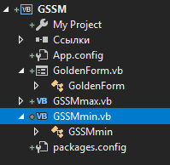

*********************Outset of the “Public Class GSSMmin”

Option Explicit On

Imports System.Math

Imports info.lundin.math

Imports System.Threading

Public Class GSSMmin

Dim func As String

Dim k As Integer

Dim SolutionOfTask As Decimal

Dim ValueOfFunction As Decimal

Dim FinalInaccuracy As Decimal

Public Sub out(SolutionOfTaskBox As TextBox, ValueOfFunctionBox As TextBox,

NumberOfIterationsBox As TextBox, AbsErrorBox As TextBox)

SolutionOfTaskBox.Text = SolutionOfTask

ValueOfFunctionBox.Text = ValueOfFunction.ToString()

NumberOfIterationsBox.Text = k

AbsErrorBox.Text = FinalInaccuracy.ToString("0E0")

End Sub

Function F(par As Double) As Double

Dim Parser As New ExpressionParser()

Parser.Values.Add("x", par)

Return Parser.Parse(func)

End Function

Public Sub start(funcBox As TextBox, LeftEndPointBox As TextBox,

RightEndPointBox As TextBox,

ToleranceBox As TextBox, k_maxBox As TextBox,

ByRef ProgressBar1 As ProgressBar, ByRef Label4 As Label)

Dim Tolerance As Double

Dim a, b As Decimal

Dim x1, x2 As Decimal

Dim YF1, YF2 As Decimal

Dim k_max As Integer

Dim CondK_Max As Boolean

Dim R As Decimal

R = (Math.Sqrt(5) - 1) / 2

CondK_Max = 0

func = funcBox.Text

a = Decimal.Parse(LeftEndPointBox.Text)

b = Decimal.Parse(RightEndPointBox.Text)

Tolerance = Double.Parse(ToleranceBox.Text)

k_max = Integer.Parse(k_maxBox.Text)

x1 = a + (1 - R) * (b - a)

YF1 = F(x1)

x2 = a + R * (b - a)

YF2 = F(x2)

k = 0

Do

k += 1

If k = k_max Then

Dim rv As Long

rv = MsgBox("Attention: It isn't possible to find a solution with the given Tolerance = " _

& Tolerance & " and for a given Number Of Iterations =" & k_max & vbCrLf _

& "Continue searching?", vbYesNo Or vbQuestion)

If rv = vbYes Then

k_max = k_max + k_max

k_maxBox.Text = k_max

Else

CondK_Max = 1

Label4.Text = "Attention: It isn't possible to find a solution with the given Tolerance = " _

& Tolerance & vbCrLf & "and for a given Number Of Iterations =" & k_max

End If

End If

If YF1 > YF2 Then

a = x1

x1 = x2

YF1 = YF2

x2 = a + R * (b - a)

YF2 = F(x2)

Else

b = x2

x2 = x1

YF2 = YF1

x1 = a + (1 - R) * (b - a)

YF1 = F(x1)

End If

FinalInaccuracy = Math.Abs(b - a)

ProgressBar1.Visible = True

ProgressBar1.Maximum = k + 0.00000001

ProgressBar1.Value = k

Thread.Sleep(0)

Loop While CondK_Max = 0 And FinalInaccuracy > CDec(Tolerance)

If FinalInaccuracy < CDec(Tolerance) Then

Label4.Text = "Answer: The minimum point of extremum find with the given Tolerance = " & Tolerance

End If

ProgressBar1.Visible = False

SolutionOfTask = x1

ValueOfFunction = YF1

End Sub

End Class

*********************Ending of the “Public Class GSSMmin”

# Раздел №7 Тестирование

1. Тест №1 функция: x^2-4*sin(x), проверка стандартных функций

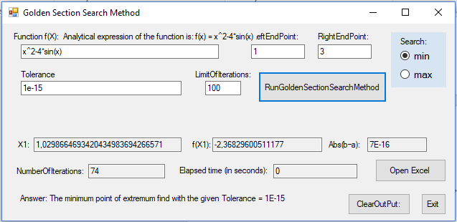

1. Тест №2. Проверка на вывод ошибки о недостаточном количестве итераций

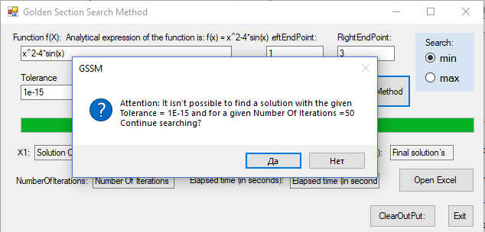

1. Тест№4. Проверка правильности целевой функции

